ARROWTOWN WILDING STRATEGY AUGUST 2017
  - Arrowtown Village Association in conjunction with Arrowtown Promotion and Business Association, Arrowtown Wilding Group, and Associated Stakeholders.
A vision for the eradication and management of Wilding Trees in the Arrowtown Area . The problem explained, the options available, the way forward.
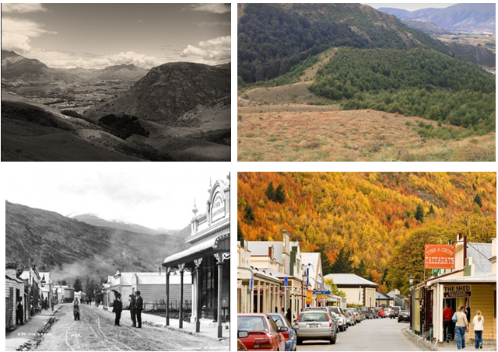
Arrowtown Wilding Strategy –
DRAFT June 2017
Arrowtown Wilding Group (AWG)

Section A Strategy Summary: 3
Section B Problem 4
Section C Background 5
Section D Scope and Purpose 6
Section E Key Partnerships 7
Section F Strategy 8
Section G Coordination with Stakeholders 11
Section H Strategy Implementation 12
Section I Funding 13
Section J Control Methods 15
Section K Outcomes/Results 17

Strategy Summary:

The issue:

- Wilding tree spread threat to biodiversity values
- Wilding Conifer spread into Arrowtown Autumn Colour faces
- Arrowtown Autumn Colour trees are themselves wilding species

Arrowtown Wilding Group (AWG) scope:

- All faces visible from Arrowtown township (see Appendices A in Strategy)
- 2 tier approach to eradication and control
- Priority One: Wilding Conifer control, including priority removal from Autumn faces
- Priority Two: Wilding Deciduous removal along with replacement with native species/non-spreading deciduous colour mix
- Work closely with Environmental Gateway project, including establishment of potential nursery for revegetation.

Collaborative approach critical to ensure community and stakeholder ‘buy-in’

“A stitch in time saves nine”… strategy will have 5 stages:

- Alert
- Educate
- Involve
- Eradicate
- Replace

A mix of methods will be necessary:

- Volunteer hand removal of trees: Arrowtown Choppers has commenced.
- Contract mechanical and spray control on more difficult and/or high priority areas

Fundraising:

- Ongoing funding required to ensure funds available to meet targets and prevent re-invasion of cleared areas

Outcomes, reporting:

- Regular updates to community and stakeholders to ensure momentum is maintained

Problem
Wilding trees have become a significant threat to both the remaining biodiversity values of the Arrowtown area as well as spreading through the ‘autumn colour’ that has become part of Arrowtown’s identity. Wilding trees are classified as species that actively spread beyond their initial location. They are not native to New Zealand, and can colonise vast areas of terrain, smothering existing vegetation. They have additional numerous negative effects, some of which can be localised, such as the loss of Arrowtown’s autumn colours. Paradoxically, much of that colour is produced by several wilding species, including sycamore, rowan, ash, and larch. However, these species are now being out-competed by wilding conifers, namely Douglas Fir.

Arrowtown for much of its existence has been characterised by a lack of either exotic conifer or deciduous tree cover. It has only been in the last forty years that the spread of wilding species has created a significant amount of forest cover on the surrounding slopes. From a historical perspective, vegetation cover with either Māori or European presence in the area has been predominately tussock grassland and grey shrubland. However, the environment surrounding Arrowtown is naturally returning to woody species. The issue is that several introduced species are threatening the remaining biodiversity. Their elimination and replacement with more suitable species will provide a significantly improved ecological outcome to the area.

The Arrowtown Autumn Colours:

The hills surrounding Arrowtown have recently come to form an integral part of the unique character that makes the town both an appealing place to live and world famous. Over the past forty years, the hills close to the township have become covered with a range of exotic deciduous tree species that provide a green backdrop in summer and a display of autumn colours.

Although a recent occurrence, and therefore do not have any historic values, they are considered by many as part of the growing heritage and history of Arrowtown. However, the trees that provide Arrowtown with its autumn colours are an accident of history. They consist of a handful of wilding species that are degrading biodiversity values and they continue to spread through wind dispersal.

The trees, and especially the autumn colours, are considered to have community value and their management is important to residents of Arrowtown. Their character also forms a component of the tourism appeal for the town, being of importance to the local economy as well as being a draw-card for the greater region.

It is widely accepted that preserving the unique character of Arrowtown is of great value to both the residents of the town and many people both locally and internationally. A compromise needs to be found that will allow Arrowtown to preserve its unique character but not act as a “weed seed source” for surrounding areas.

Background
Prior to human arrival in New Zealand, the native ecology of the area is likely to have been a mixture of beech forest, some mixed broadleaf/podocarp forest, and shrubland with tussock. Substantial parts of the basin were likely kept clear by the effects of moa browsing and frosts, while slopes would have been forested up to approximately 1000 metres. Above that would have been more shrubland blending into herb fields towards the snowline. Following Maori arrival, much of the native forest was cleared through fire. Those areas were colonised by adaptive species such as spear-grass, manuka, and matagouri, part of a natural process that would have eventually led too much of the area being reforested. However, the arrival of Europeans and repeated clearance of extensive tracts of land for new exotic grasses saw much of the remaining native vegetation cleared away.

When the Arrowtown Township was founded, the surrounding hillsides were bare of woody vegetation, covered instead with tussock grasslands. Repeated burning events saw the establishment of huge swathes of grasslands, tussock at higher elevation, and exotic grasses lower down, that prevented revegetation of woody species and natural tree cover. This also saw the extensive loss of soil fertility through erosion, removal of nutrients, and introduced pests such as rabbits. European settlers also brought a suite of exotic trees and shrubs, both purposefully and accidentally. Once these early specimens grew to a sufficient age, they began to seed into the cleared areas. They rapidly established dominance in areas that had been severely depleted of original vegetation.

The subsequent forestry plantation of Douglas Fir on Coronet Peak in the 1980s saw these tress mature, and begin to spread significant amounts of seed over into the Arrowtown catchment. Some of this seed has now grown and matured, and begun to spread seed of its own. Without intervention, exotic conifer forest will dominate the remaining vegetation in the basin as well as spread well above the natural tree line. The spread will continue outside the basin towards the north and east, affecting additional areas.

Control has been undertaken by both QLDC and Soho Property Ltd This has focused on the margins around Coronet Forest and in the backcountry between Arrowtown and Wanaka. Previously, volunteers have helped clear parts of German Hill by hand.

Wilding trees for the Wakatipu are addressed in several local government documents. Chapter 34 of QLDC’s operative district plan outlines prohibited species. In the ORC 2016/2017 Annual Plan – Queenstown will receive $40,000 for wilding control. At a wider level the National Wilding Conifer Group supports the active management of conifer infestations in New Zealand with funds from MPI and DOC.

Scope and Purpose
The scope of the Arrowtown Wilding Project is defined in part by the boundaries of the Arrow River catchment. More specifically, after discussion with the Wilding Conifer Group (WCG) and Queenstown Lakes District Council (QLDC) this project scope is defined by those areas visible from the Arrowtown Township. This includes the Crown Terrace, Tobin’s Face, Mt Beetham, German Hill, Feehly Hill, and the slopes of the unnamed point behind Butel Park (see map in Appendix A).

This strategy identifies two groups of wilding tree species (see Appendix B).

The first group are classified as the exotic conifers and include Pinus nigra (Austrian Pine), Pseudotsuga menziesii (Douglas-fir), Pinus radiata, Pinus ponderosa, and Larix sp. (Larch). These require the most urgent attention in terms of control and elimination, as they spread the widest and the quickest. It is noted that trees within this group are currently rapidly establishing within Arrowtown’s highly visible ‘autumn colour’ faces and require urgent control.

The second group contains those wilding deciduous trees noted for their autumn colour. These include rowan, sycamore, and crack willow, and are in many instances classified as weed species. These species also need to be controlled. However, they are currently of a lesser threat in terms of expansion than the exotic conifers but will require a definitive management plan focused on removal and replacement.

Key Partnerships
- Arrowtown Community
- Arrowtown Village Association
- Arrowtown Promotion and Business Association
- Wilding Conifer Group (WCG)
- Queenstown Lakes District Council (QLDC)
- Otago Regional Council
- QEII National Trust as holders of Open Space agreements, Mahu Whenua covenants.
- Soho Property Ltd as occupiers of Glencoe and Coronet Peak Stations, Glencoe Land Development Company
- Department of Conservation
- Land Information New Zealand as Lessor of Crown Pastoral leases
- Private Landowners including those on the Crown Range
- NZ Wilding Conifer Management Group

Strategy
The focus of this strategy is on visible slopes around Arrowtown as well as dealing with sources of wilding conifers on private land within the Arrowtown boundaries. The fundamental component of wilding control is the mantra that a stitch in time saves nine. This strategy will be undertaken in concert with the Wilding Conifer Group (WCG) acting in an advisory role. They will provide guidance on the most effective means to deal with the problem based on their extensive experience. However, this group will act independently in terms of funding and outcomes.

This strategy utilises a model adapted from the one produced by the WCG. This project will have five stages.

Alert - bring awareness to the community about the extent of the problem;
Educate – involve local stakeholders and keep them informed. This includes community and educational groups;
Involve – harness the power of volunteers in conjunction with landowners and local government to tackle the problem;
Eradicate – remove all wilding conifers and other wilding exotics;
Replace – replant those cleared areas with a mix of native vegetation and non-spreading deciduous exotic trees to improve biodiversity and provide enriched autumn colour (see Appendix C).

To provide accurate information about the extent and severity of the spread of wilding trees to help Alert the community to the problem, it is suggested that a baseline recording be undertaken. This will involve photographic documentation of the target areas. In addition, if funding can be accessed, then aerial imagery of the projects geographical scope will be obtained from a fixed wing or drone survey. This information will be incorporated into a localised GIS system allowing accurate recording of progress.

As part of the first three stages of the strategy (Alert, Educate, Involve), information will be disseminated to the local community. The suggested methods for this dispersal are through social media and regular town meetings at the Athenaeum Hall. These meetings will allow the strategy to be discussed, as well as informing the public on the current scope of the problem, as well as plans and objectives to deal with the issue. Following progression of the project, there will be the presentation of results to inform community about the degree of success. In addition, communication with the local schools and community groups will be undertaken to raise awareness and encourage community involvement.

To adequately deal with the problem now, and prevent further costs and effort in the future, the Eradication component of the strategy will focus on the elimination and control of all wilding tree species. This will be done in a two-phased effort.

The first phase will involve the removal of every source of wilding conifer in the area, with immediate focus on coning trees. Removal of wilding conifers within the autumnal faces is a priority. This needs to precede the second stage of the strategy (outlined below), which will see control/eradication/replacement of deciduous wildings commence.

Coronet Forest

The removal and replacement of wilding trees is a substantial task, and will require the cooperation and involvement of both public entities and private landowners. This strategy will only work in the event that the Coronet Forest is removed, and removed quickly. Every year the forest remains will contribute significant seed source and further enlarge the problem. The initial targets will be all coning wilding conifers. Should the forest fail to be removed quickly, each year will see a substantial exponential increase in control costs and extent.

Wilding trees need to be identified on both public and private land. Consultation with private landowners will need to be undertaken to help remove these seed sources and replace them with suitable non-spreading species.

A list of suitable replacement species can be found in Appendix C.

On land under pastoral lease subject to QEII covenants, with the agreement and cooperation of involved parties, clearance of coning conifers would be undertaken. Substantial investment on control of wilding conifers has already been undertaken by Soho Property to date.

On public land, with the agreement and cooperation of involved parties, clearance of coning conifers would be undertaken. This has already begun in a small way in the Sawpit Gully area with hand clearance and poisoning of wilding conifers near German Hill. However, to adequately deal with the problem, this will need to be scaled up considerably, and require funding sources. The only effective means to deal with the problem at its current scale is to chemically spray in many areas (see Section I for control methods).

The Involvement aspect is a critical component to the success of this strategy. The ‘Arrowtown Choppers’ group has already undertaken ground clearance beginning in 2017. The continued support and guidance of this group is required to allow them to operate with utmost efficiency. Provision of additional materials such as tools and consumables such as poison will need to be funded. Training of volunteers in the use of certain control methods such as basal bark spraying and ‘drill and fill’ techniques will also need to be affected.

Once conning conifers have been removed, the second phase of the strategy will be initiated. This will involve the removal of sections of wilding trees including species such as rowan and sycamore through mechanical means and poison. These sections will be replanted as part of the Replacement component of the strategy using a mixture of native species and exotics that are determined as non-spreading (see Appendix C). In time, these sections will become established, providing increased bio-diversity and colour to the hillsides.

In the event that funding is secured to allow the removal of existing wilding species and Replacement of vegetation on the hillside, a nursery will need to be established in the immediate area. The most accessible place for this would be along the bank of Bush Creek opposite the Chinese Village. This land is partly owned by QLDC, partly under Mahu Whenua covenant on Crown Pastoral Lease. Agreement between affected parties would need to be reached.

Timeline

Due to the early stage of the project, it is difficult to accurately identify timing for completion of work, but a draft timeline is proposed below.

2017 – Finalise strategy following community consultation
Establish Memorandums of Understanding (MOU’s) with all key stakeholders
Determination of approximate costs for control work in Phase 1
Apply to main funding bodies to finance Phase 1 works
Hold community meeting in December to provide an update on progress

2018 – Pending successful funding applications, begin contractor control works
including initial survey documentation and elimination of coning conifers.
Continue and support volunteer engagement in wilding removal around tracks, waterways, and around existing native vegetation
Hold at least two community meetings to provide updates on progress
Continue to apply for long term funding to meet required costs of ongoing control
Monitoring of control success through photographic documentation
Begin feasibility investigation of nursery establishment for revegetation projects

2019 – Repeat goals of 2018, updating funding and control methods as needed.
Consider potential of native revegetation through seed dispersal following initial results of ongoing Wakatipu Beech Seeding Project
If nursery considered viable, seek funding for construction and maintenance

2020 – Consider beginning implementation of Phase 2 – revegetation of slopes with
species identified in Appendix B and C.
Adjust strategy goals as appropriate depending on success of prior years
Ongoing community involvement including progress updates and volunteers engagement
Ongoing funding for removal of remaining wilding species and their replacement

2021+- Continue goals above as needed to achieve complete removal of wilding
species

Coordination with Stakeholders
To maximise the control of wildings in the area, close coordination will need to be undertaken principally with the WCG (as part of QLDC involvement) and the station manager for Coronet Peak and Glencoe.

Advice and guidance is sought from the WCG to maintain best practice methods and identification of areas for control. In addition, coordination and support for control on Coronet Peak and Glencoe Stations will also be undertaken with Soho Property and the QEII National Trust. Local council involvement will be through the Arrowtown council representative. DOC involvement will be through their local control officer. Private landowners will be contacted directly. Where advice is offered, other bodies such as Landcare or Scion Research will be involved in the project.

Strategy Implementation
The first portion of the strategy has already begun with hand clearance being undertaken in sensitive areas. Following a hiatus over the winter, volunteer work will begin again in the spring centred on German Hill. A scope of works for the next ten years will be produced identifying those areas in most need of hand clearance. Cleared areas will also require ongoing maintenance to prevent re-infestation. There is also consideration of implementing a similar scheme to the WCG “Adopt a Plot” for volunteers.

In conjunction with ground clearance, the next stage of implementation is acceptance of the strategy by the local community. A town meeting addressing the strategy will need to be held outlining the proposed course of action.

Following acceptance of the strategy, a significant amount of funding will need to be applied for based on the first phase of the strategy, which is focused on eliminating coning wilding conifers. A methodology and approach will need to be identified and a procedure established. With the help of WCG, costing for this stage can be determined, and funding sought to cover costs.

Consideration is to be given to acquiring funding for the employment of a part-time co-ordinator given the scope and scale of the strategy.

Following the successful clearance of wilding sources, the next stage of sectional wilding clearance will need to be initiated. This will require additional funding along with concurrent communication with the local community. Revegetation efforts (Replacement) will also be part of this stage of implementation. The viability of a designated nursery will need to be determined.

Funding
Volunteers and associated work parties are important, but large funding sources will be required to remove and control wilding species. Voluntary input is critical and not to be underestimated. Collaborative efforts such as track creation in parallel with wilding control will be encouraged.

Funding Structure;

The Arrowtown Wilding Group (AWG) has received formal support from the Arrowtown Village Association (AVA) that allows use of existing AVA bank accounts and charitable status for fundraising purposes. Any funding applications will occur in the name of the AVA as overall umbrella organisation for the wider AWG stakeholders.

Short Term Funding;

The Arrowtown Choppers group is already established and undertaking regular control of wilding conifers in selected areas. Generous sponsorship for equipment has already been achieved and no further short term funding is required for initial setup.

The promotion of the Arrowtown Choppers group by AWG, AVA, and Arrowtown Promotion and Business Association (APBA) will encourage community involvement as well as education on the Wilding issue as it applies to Arrowtown. Support for the proposed Environmental Gateway project maybe encouraged and beneficial.

Long Term Funding;

Awareness of the Wilding issue as it applies to Arrowtown is critical for ongoing funding. It is envisaged that the WCG will provide support and advice on funding applications.

Any lack of secure funding required to maintain ongoing control and sustain the gains of control efforts is the greatest risk to the long-term success of this strategy.

Consideration is to be given to the paid employment of a co-ordinator to oversee all aspects of the strategy, from fundraising through to implementation.

Funding will also be sought for revegetation programs along with the exploration of establishment of a potential nursery area. Initial funding bodies will include, but not limited to: the Central Lakes Trust, Southland Community Trust, Lotteries, and Sky City Community Trust. Funding from additional groups may also be sought, including local government, and governmental agencies such as DOC and LINZ.

The formation of the AWG, with AVA structure support, means the group can apply to funding agencies for additional support for specific projects, and/or focus areas, as the strategy evolves.

Both local and national funding sources will need to be canvassed on an annual basis. The location and iconic status of Arrowtown, along with the large area of Crown-owned land visible, will provide adequate reason for such national funding approaches.

The existing financial input from landowners in the district, in the form of control work, is noted and appreciated.

With strong collaboration between the AWG and stakeholders, and positive funding outcomes, we will be able to deliver wilding control and work towards total eradication. Our vision is the removal of all wilding trees whilst maintaining the unique and valued Arrowtown character.

Control Methods
In sensitive areas including tracks, waterways, and around existing patches of native forest, hand clearance will be undertaken. It is recommended that a clearance corridor of five metres be established along existing trails and waterways. A clearance corridor of twenty metres is recommended around existing native forest to prevent damage to the regeneration that is occurring on the margins.

Significant numbers of trees where accessible on the ground can be cleared through the use of basal bark spray. Either trained volunteers or contractors depending on organisation and funding could undertake basal spray operations.

In areas which are not accessible to ground crews, aerial spray would be required. From recent discussions with specialists, control from helicopters offers the most efficient means of control. Where areas are inaccessible, areas can be sprayed using drones.

Optimum periods for control will be determined through discussion with the WCG and appropriate contractors.

Once coning wilding conifers have been controlled, sectional clearance of remaining wilding trees will begin. This would begin at the northerly and easterly margins of the current spread, and work progressively to the south and west. This sectional strategy will be a mid-to-long term goal of the project. However, it will eventually remove all sources of wilding species, and minimise visual impact on the adjacent hillsides.

A summarised table of control methods as shown in the WCG strategy is shown below.

Table 1. Summary of the wilding tools currently used in the Wakatipu for wilding control.
 | Wilding Control Tools
Ground Crew |  |  | Trees removed using chainsaws, hand tools, lopper and saws, every green needle must be removed from the stump
Skid Hopping |  |  | Using helicopters to move crew ground crew members to areas with trees, where trees are hard to access
Ground Basal Bark |  |  | Ground technique, the bottom of the tree is treated with herbicide
Scrub Bar |  |  | Best used on flat or following country, the scrub bar cuts the tree and then chemical is applied to the stump so that if any green foliage is left the tree will not survive.
Helicopter Boom Spray |  |  | Herbicide is applied via boom from a helicopter (this method of application is commonly used in agriculture).
Helicopter Spot Spraying Lance /Wand |  |  | Herbicide is applied directly onto the tree using a lance/wand from a operator sitting in the helicopter
Spot Spraying Pole |  |  | Herbicide is applied directly onto the tree using a pole which is attached to the front of the helicopter
Machine, Digger/Mulched |  |  | Used to remove dense stands where wildings are accessible
Stem Poisoning |  |  | Most useful for large trees in difficult access/rocky terrain, and in bush/scrublands where felling can create light- wells and promote new wilding establishment
 | Site Management Tools
Burn |  |  | Small wildings and possibly dense stands of medium/large trees
Fertilise |  |  | Mainly prevention, effective by increasing competition of existing vegetation (especially grasses).
Grazing |  |  | Mainly prevention, only effective on very young seedlings (1-2 years old).

Outcomes/Results
It is recommended that a ten-year plan be written with targeted goals, with the results then matched against expected outcomes. This plan will incorporate this strategy, and be further developed and refined as expertise builds and outcomes are realised. This will also provide a series of maps of the project extent showing sectional areas to be cleared in sequence.

For revegetation, it is recommended that a mix of native vegetation and exotic non-spreading trees be planted. The exotic trees could be planted in clusters to provide a swath of colour in the autumn.

There is currently an operational pilot project to determine the viability of sowing native beech seed into sprayed stands of wilding conifers. If this proves to be a viable means of reseeding, then such a technique could be adopted as part of the revegetation strategy. Another means of reforestation is the planting of beech seedlings within the cleared cover. Mountain beech, planted on the south face of Feehly Hill, is now emerging from the underlying vegetation. This could be expanded into those cleared sections in combination with the clusters of non-spreading exotics.

A record of all meetings, documentary photographs, and information relevant to the project will be kept and stored in an appropriate facility. Discussion will need to be undertaken with the AVA and the Lakes District Museum to determine a suitable location.

Appendix A – Map

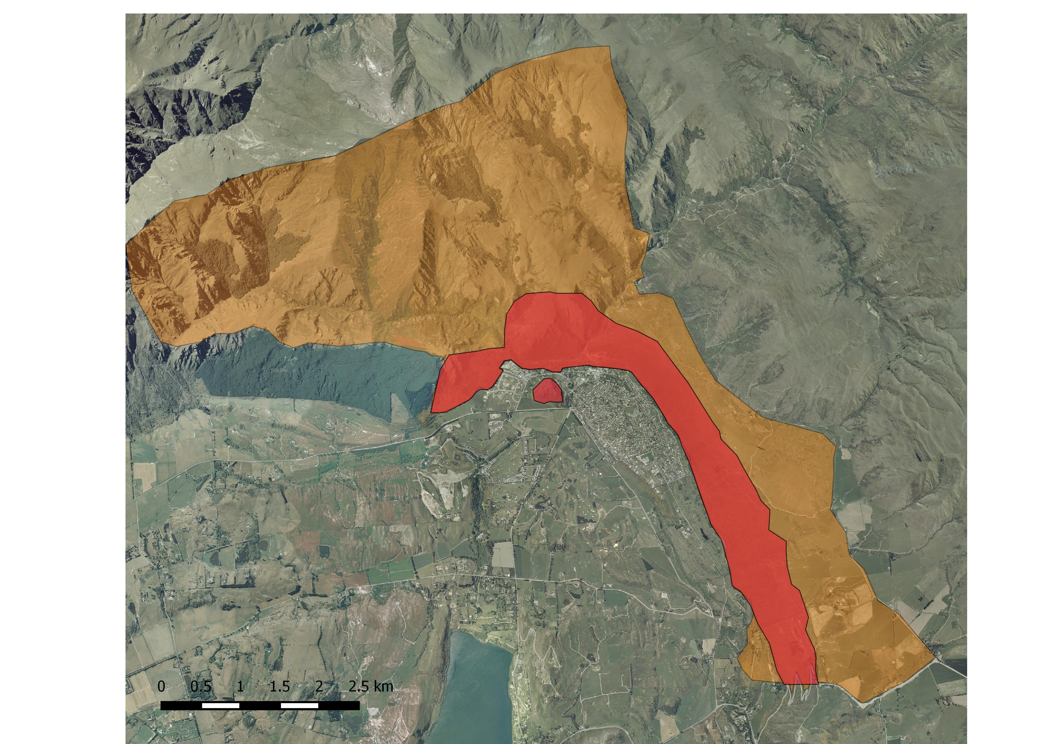

Wilding Control Area to be
encompassed by the strategy
Border area highlights
High visibility ‘autumn colour’
faces/area
Appendix B – Wilding Species
a. Contorta or lodgepole pine (Pinus contorta)
b. Radiata Pine (Pinus radiata)
c. Scots pine (Pinus sylestris)
d. Douglas Fir (Pseudotsuga menziesii)
e. European larch (Larix decidua)
f. Corsican pine (Pinus nigra)
g. Bishops Pine (Pinus muricate)
h. Ponderosa Pine (Pinus Ponderosa)
i. Mountain Pine (Pinus mugo)
j. Maritime Pine (Pinus pinaster)
k. Sycamore
l. Hawthorn
m. Boxthorn
n. Rowan (Sorbus aucuparia)

Appendix C – Suggested replanting species
Native species

- Fuscospora cliffortioides - mountain beech
- Plagianthus regius - lowland ribbonwood
- Coprosma linariifolia
- Cordyline australis - cabbage tree
- Griselinia littoralis - broadleaf
- Hoheria sexstylosa - ribbonwood
- Pittosporum tenuifolium - kohuhu
- Podocarpus laetus - mountain totara,
- Sophora microphylla - South Island kowhai
- Aristotelia fruticosa - mountain wineberry
- Coprosma crassifolius
- Coprosma propinqua
- Coprosma rugosa
- Coprosma virescens
- Corokia cotoneaster
- Discaria toumatou - matagouri
- Dracophyllum longifolium
- Halocarpus bidwillii
- Hebe salicifolia
- Hoheria glabrata - mountain ribbonwood
- Leptospermum scoparium - manuka
- Olearia aviceniifolia
- Olearia arborescens
- Olearia fimbriata
- Olearia fragrantissima
- Olearia lineata
- Olearia odorata
- Phyllocladus alpinus
- Pseudopanax ferox
- Carmichaelia petriei
- Hebe odora
- Heliohebe cupressoides
- Melicytus alpinus
- Muehlenbeckia complexa
- Ozothamnus vauvilliersii/fulvida
- Phormium cookianum
- Austroderia richardii
- Chionochloa rigida
- Festuca novae-zelandiae
- Poa colensoi

Exotic Trees

- Acer platanoides – Norway Maple
- Acer rubrum – American Red/Swamp Maple
- Acer saccharum - Sugar Maple
- Alnus rubra – Red Alder
- Cotinus coggygria ‘Purpurea’ – Purple smoke bush
- Fagus sylvatic ‘Purpurea’ – Copper Beech
- Fraxinus angustifolia ‘Raywoodii’ – Claret Ash
- Liquidambar styraciflua ‘Aurora’ – Sweet Gum
- Populus x euramericana ‘Argyle’ = Argyle Poplar
- Populus ‘Eridano’ – Eridano Poplar
- Populus yunnanensis – Chinese Poplar
- Quercus ellipsoidalis – Northern Pin Oak
- Quercus palustris – Pin Oak
- Quercus petraea x robur – Hybrid English Oak
- Quercus robur – English/Common Oak
- Quercus rubra – Red Oak
- Ulmus x hollandica ‘Dodoens’ – Dutch Elm
- Ulmus parvifolia – Chinese Elm
- Ulmus procera ‘Louis van Houtte’ – Golden Elmn Elm

